**Team Leader**

Muhammad Yasin Wahidullah (SP20-BSE-059)

**Group Members**

Adnan Haider (SP20-BSE-037)

Zakir Khan (SP20-BSE-065)

Junaid Khan (SP20-BSE-066)

Mohsin Khan (SP20-BSE-067)

Zeshan Aziz (SP20-BSE-071)

**THESIS**

## Introduction

Railway reservation system is developed for to automate the railways reservation system. It includes modules required to successfully operate railways reversion process smoothly. It has train master to add modified train information, train schedule to enter train journey details include all the station name, arrival time and departure time. It includes automatic fair calculation as per the distance between two stations. Reservation module consists of automatic seat number and coaches no allocation system. Daily schedule for updating of not conform seat and coach no. All master like train master, Train schedule, reservation fees, cancellation fees, charges can be modified individually from front end and changes reflect in all modules immediately.

Therefore proposed “Railway reservation system” has been designed to automate the process of railway for ticket reservation and back-office activities. System can make the daily activities efficient and provide the fast response. The “Railway reservation system” has been developed to override the problems prevailing in the practicing manual system. This software is supported to eliminate and, in some cases, reduce the hardships faced by this existing system. Moreover, this system is designed for a particular need of a company to carry out operations in a smooth and effective manner. The application is reduced has much as possible to avoid errors while entering the data. It also provides error messages while entering invalid data. No formal knowledge is needed for the user to use this system.

Thus, by this all it proves it is user friendly. Railway reservation system, has described, can lead to error free, and secure, reliable, and fast managing system. It can assist the user to concentrate on the other activities rather to concentrate on the record keeping. Thus, it will help organization in better utilization of resources. Every organization, whether big or small, has challenges to overcome and managing the information of ticket, train, customer, seat, payment. Every Railway reservation system has different train needs, therefore we designed exclusive employee management systems that are adopted to your managerial requirements.

## Vision and Business Case

**Executive Summary**

This report shows the case study of Railway Reservation System. This System is basically concerned with the reservation of railway tickets and Live Enquiries for the Passenger.

In this we are discussing that how the reservation is done and What are the rules and regulations and procedure for reservation.

This project aims to provide a mechanism for the railway management to deal with number of tasks efficiently using this system.

The database should be stored in computer rather than in register/manually.

**Features**:

1. Searching of data is easy
2. Passenger don’t have to wait for a long time
3. Information is accurate
4. It is a fast process
5. Data efficiency is more
6. Immediate Response for Enquiries Complaints can be submitted

## Use-Case Model

## Functional Requirement

* An account associated
* One account cannot be associated with multiple users
* Search results should enable users to find the most recent and relevant booking options
* System should enable users to book / pay for their tickets only in a timeboxed manner after tickets being added to the cart
* System should only allow users to move to payment only when mandatory fields such as date, time, location has been mentioned
* System should consider time zone synchronization when accepting bookings from different time zones
* Booking confirmation should be sent to user to the specified contact details

## Supplementary Specification

## Non-Functional Requirement

* Use of captcha and encryption to avoid bots from booking tickets
* Search results should populate within acceptable time limits
* User should be helped appropriately to fill in the mandatory fields, in case of invalid input
* System should accept payments via different payment methods, like PayPal, wallets, cards, vouchers, etc.
* System should visually confirm as well as send booking confirmation to the user's contact

**MODULES IN PROJECT**

The modules included in this project is:

1. Register Module | SP20-BSE-067 | MOHSIN KHAN
2. Login Module | SP20-BSE-037 | ADNAN HAIDER
3. Reservation Module |SP20-BSE-059 | MUHAMMAD YASIN WAHIDULLAH
4. Manage Train | SP20-BSE-065 | ZAKIR KHAN
5. Book Ticket | SP20-BSE-071 | ZEESHAN AZIZ
6. Cancel Ticket | SP20-BSE-066 | JUNAID KHAN

**BRIEF**

**MUHAMMAD YASIN WAHIDULLAH | SP20-BSE-059**

This Use Case will begin when the passenger wants to reserve a Seat. He will need to fill the reservation form to enter his current city and destination city, select time slot, select seat, and confirm the payment through available payment methods and print the provided ticket.

The details of the available seats, time of departure of train, and cost of ticket will be provided by the system.

**ZAKIR KHAN | SP20-BSE-065**

This Use Case starts when the admin will Manage the train detail. The admin will add train details, ticket details, manage passenger details, ticket prices and more which results in proper resource management of booking data.

The details of the train will be managed by the admin

**JUNAID KHAN | SP20-BSE-066**

This Use Case starts when the passenger wants to cancel the ticket. Passenger will click the ticket details and check to whether cancel the ticket or not. If the passenger wants to cancel the ticket, he/she will click the cancel the button Infront of his/her ticket details. The ticket will proceed to be cancelled and ticket price will be refunded with deduction according to the time.

The ticket of the passenger will be cancelled.

**MOHSIN KHAN | SP20-BSE-067**

This Use Case will begin when the passenger wants to register account. User will enter his details That include Email, Username, Contact Number, CNIC and Password and will click confirm.

The User has successfully registered to the system

**ZEESHAN AZIZ | SP20-BSE-071**

This use case will begin when the passenger wants to book a ticket. Passenger will click the book ticket button and fill his details that include his current city and destination city. Then passenger will select his seat and confirm booking.

The ticket of the passenger will be booked.

**ADNAN HAIDER | SP20-BSE-037**

**Brief Description**

This use case describes how a passenger logs into the System.

**Basic Flow**

This use case starts when an actor wishes to log into the System.

It models the following actions:

* Enter a username
* Enter a password
* Click on the Login button
* Send user login info
* Validate user password
* User login accepted
* Redirect to the target page
* User login rejected
* Clear the password box and inform the user about an unaccepted user-password combination

**Alternative Flows**

**Invalid Name / Password**  
If in the *Basic Flow*the actor enters an invalid name and/or password, the system displays an error message.

The passenger can reset the password.

The actor can choose to either return to the beginning of the *Basic Flow*or cancel the login, at which point the use case ends.

**USE CASE DIAGRAM**

**ADNAN HAIDER | SP20-BSE-037**

**MUHAMMAD YASIN WAHIDULLAH | SP20-BSE-059**

**ZAKIR KHAN | SP20-BSE-065**

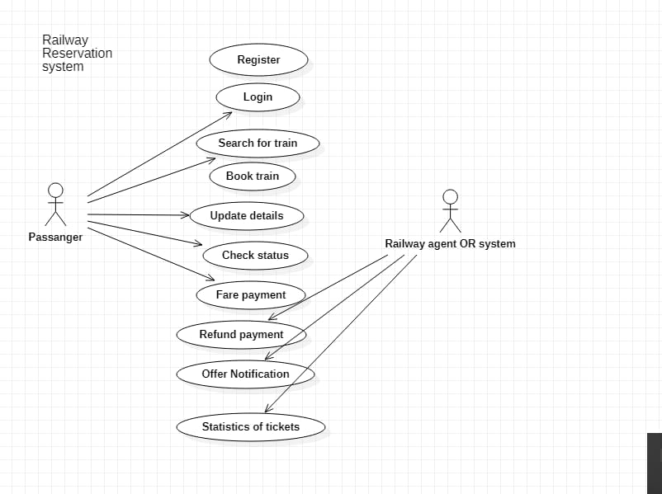

**JUNAID KHAN | SP20-BSE-066**

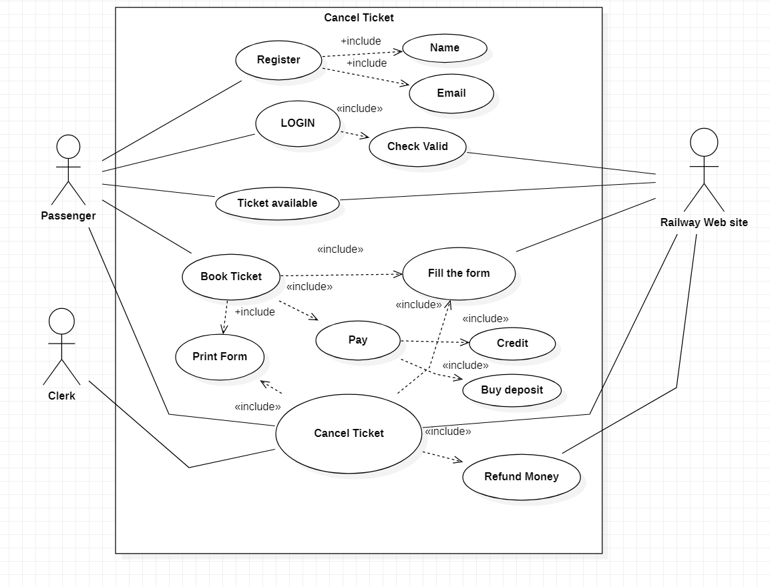

**MOHSIN KHAN | SP20-BSE-067**

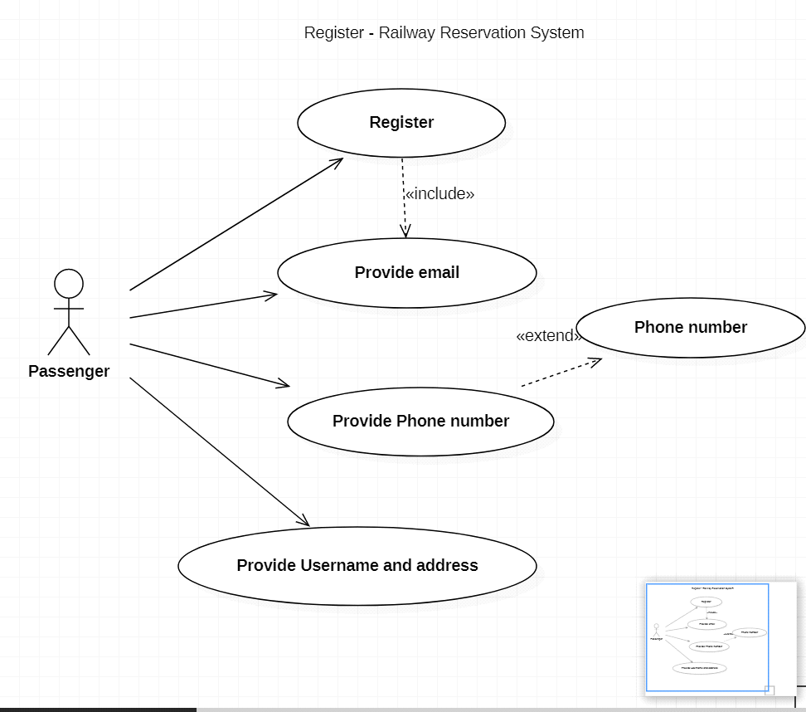

**ZEESHAN AZIZ | SP20-BSE-071**

**FINAL USE CASE DIAGRAM**

**FULL DRESSED DIAGRAM**

**ADNAN HAIDER | SP20-BSE-037**

|  |  |
| --- | --- |
| **Name** | Login |
| **Scope** | Connect Me |
| **Level** | User-goal |
| **Stakeholders and Interests** | Passenger |
| **Stakeholders and Interests** | User: He /She want to login to use services. |
| **Preconditions** | User has launched the application and is ready a register user. |
| **Postconditions** | User role was set and associated with user session. |
| **Main Success Scenario** | 1. This use case starts when the user wants to login for the services 2. User provides credentials and press the login button. User is logged in. |
| **Extensions** |  |
| **Special Requirements** | Maintainability, Reliability and Accountability |

**MUHAMMAD YASIN WAHIDULLAH | SP20-BSE-059**

|  |  |
| --- | --- |
| **USE CASES** | **COMMENT** |
| Use Case Name | Reserve Seat |
| Scope | Railway Reservation System |
| Level | User Goal |
| Primary Actor | Passenger |
| Stockholders and Interests | Passenger: wants to reserve a seat in a train  Admin: wants the detail of the passenger |
| Preconditions | The user must be registered and logged in |
| Success Guarantee | The seat of the user will be successfully reserved |
| Main Success Scenario | The user will provide details about his seat, location, pay the bill, and then his seat will be successfully reserved |
| Extensions | If the details are not correct the reservation will be failed |
| Special Requirements | Reliability, Maintainability, and Usability |

**ZAKIR KHAN | SP20-BSE-065**

|  |  |
| --- | --- |
| **USE CASES** | **COMMENT** |
| Use Case Name | Manage Train |
| Scope | Railway Reservation System |
| Level | User Goal |
| Primary Actor | Passenger |
| Stockholders and Interests | Admin: wants to manage the details of the train. i.e. add train, delete train, etc. |
| Preconditions | The user must be registered to the system |
| Success Guarantee | The details of the train will be successfully managed |
| Main Success Scenario | The admin will provide the details of the train |
| Extensions | If the details are not correct user will repeat the steps |
| Special Requirements | Maintainability, Controllable and Usability |

|  |  |
| --- | --- |
| Use Case ID: | 1 |
| Use Case Name: | Cancel Ticket |
| Actors: | Passenger |
| Description: | This prompts you to the home page of the application if the email and password asked are valid |
| Trigger: | This is a Button On-Click event |
| Pre-Conditions: | The user should have account on Train’s portal |
| Post-Conditions: | User is directed to home page of the application if the log in is successful |
| Normal Flow: | 1. User enters email 2. User is directed to the home page |
| Alternative Flows: | 2a. If the user has forgotten the password:   1. User is required to go through “Forget Password” procedure |
| Exceptions: | 1a. If the email provided by the user is in incorrect format:   1. User is asked to re-enter his email/password   1b. If the email/password section is left empty:   1. The user is asked to enter his email/password |
| Includes: | Authentication |
| Special/Quality Requirements (Other Information): | * Information is forward for authentication within 3 seconds |
| Assumptions: | The user has submitted his information to validate and sign in |

**JUNAID KHAN | SP20-BSE-066**

**MOHSIN KHAN | SP20-BSE-067**

|  |  |
| --- | --- |
| **USE CASES** | **COMMENT** |
| Use Case Name | Register |
| Scope | Railway Reservation System |
| Level | User Goal |
| Primary Actor | Passenger |
| Stockholders and Interests | Passenger: wants to register an account  Admin: wants the detail of the passenger |
| Preconditions | The user daetails must be correct. |
| Success Guarantee | The user will be allowed to use the application and can make reservation for the seats |
| Main Success Scenario | The user will provide details, like CNIC number, email,phone number and easy paisa or bank account number |
| Extensions | If the details are not correct the registration will be failed |
| Special Requirements | Reliability, Maintainability, and Usability |

**ZEESHAN AZIZ | SP20-BSE-071**

|  |  |
| --- | --- |
| **USE CASES** | **COMMENT** |
| Use Case Name | Booking ticket |
| Scope | Railway Reservation System |
| Level | User Goal |
| Primary Actor | Passenger |
| Stockholders and Interests | Passenger: wants to book a ticket  Admin: wants to verify ticket details |
| Preconditions | The passenger has registered and logged in |
| Success Guarantee | The passenger has successfully booked a ticket. |
| Main Success Scenario | The user will provide details about his seat, destination and address and ticket will be booked |
| Extensions | If the details are entered wrong booking will fail and all steps will be repeated |
| Special Requirements | Maintainability, usability, and reliability |

**DOMAIN MODEL**

**ADNAN HAIDER | SP20-BSE-037**

**MUHAMMAD YASIN WAHIDULLAH | SP20-BSE-059**

**ZAKIR KHAN | SP20-BSE-065**

**JUNAID KHAN | SP20-BSE-066**

**MOHSIN KHAN | SP20-BSE-067**

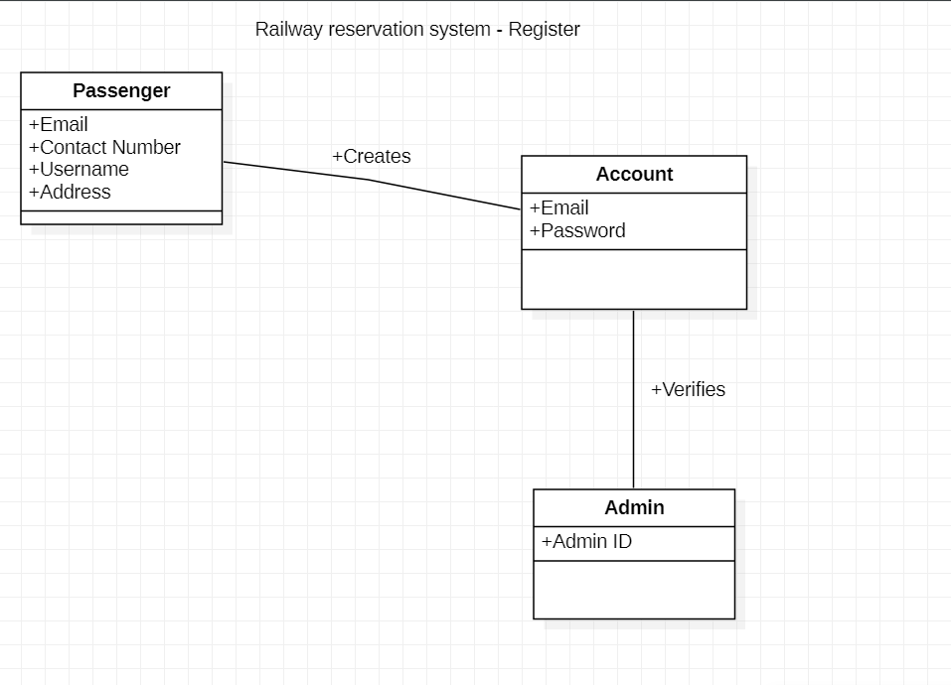

**ZEESHAN AZIZ | SP20-BSE-071**

**FINAL DOMAIN MODEL**

**SYSTEM SEQUENTIAL DIAGRAM**

**ADNAN HAIDER | SP20-BSE-037**

**MUHAMMAD YASIN WAHIDULLAH | SP20-BSE-059**

**ZAKIR KHAN | SP20-BSE-065**

**JUNAID KHAN | SP20-BSE-066**

**MOHSIN KHAN | SP20-BSE-067**

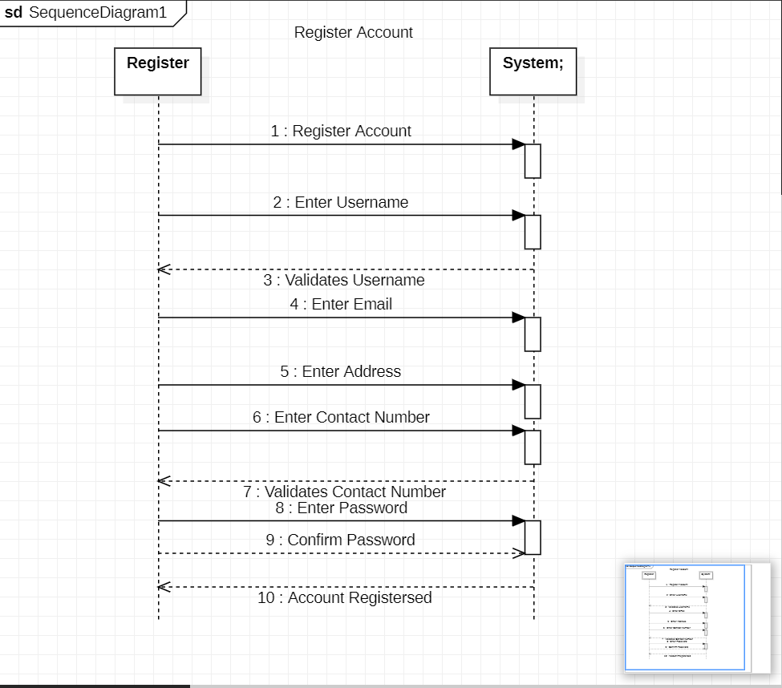

**ZEESHAN AZIZ | SP20-BSE-071**

**OPERATION CONTRACTS**

**ADNAN HAIDER | SP20-BSE-037**

**Operation**: User login (username: var password: Var)

**Cross References**:

Use Case: Login User panel

Scenario: Process User Login

**Preconditions**: System should ask to login when the system starts.

**Post conditions:** Login instance has been created for User login operation. Login instance was associated with the User (association formed).

**MUHAMMAD YASIN WAHIDULLAH | SP20-BSE-059**

**OPERATION –** Select Seat

**CROSS REFERENCE –** Reserve a Seat

**PRECONDITION –** the passenger must be registered and logged in.

**POSTCONDITION –** the seat has been reserved by the passenger

**ZAKIR KHAN | SP20-BSE-065**

**OPERATION –** Submit Details

**CROSS REFERENCE –** Manage Train

**PRECONDITION –** The admin must be logged in

**POSTCONDITION –** the details of the train has been submitted successfully.

**JUNAID KHAN | SP20-BSE-066**

**OPERATION –** Click Cancel

**CROSS REFERENCE –** Cancel ticket

**PRECONDITION –** the passenger must be registered and logged in and must have booked a ticket

**POSTCONDITION –** the ticket will proceed to be cancelled

**MOHSIN KHAN | SP20-BSE-067**

**OPERATION –** Fill Form

**CROSS REFERENCE –** Register

**PRECONDITION –** the passenger must enter the system

**POSTCONDITION –** the registration form will be filled correctly, and passenger will be registered to the system

**ZEESHAN AZIZ | SP20-BSE-071**

**Operation** location, adding, payment

**Cross reference** book ticket

**Pre-condition** the passenger has registered and logged in

**Post condition**  1. the passenger will tell the destination (location)

2. user id

3. seat availabilities

4. approving payment

5. end of purchasing

**PACKAGE DIAGRAM OF PROJECT**

**REPOSITRY GITHUB**

[**https://github.com/YasinWahid/Railwayressys.git**](https://github.com/YasinWahid/Railwayressys.git)